Pruebas Documentadas

Nombre: Chicaiza Cristopher

Materia: Integración de Sistemas

Tarea: Examen Practico Progreso 2

**Ejecución SQL**

SoapService

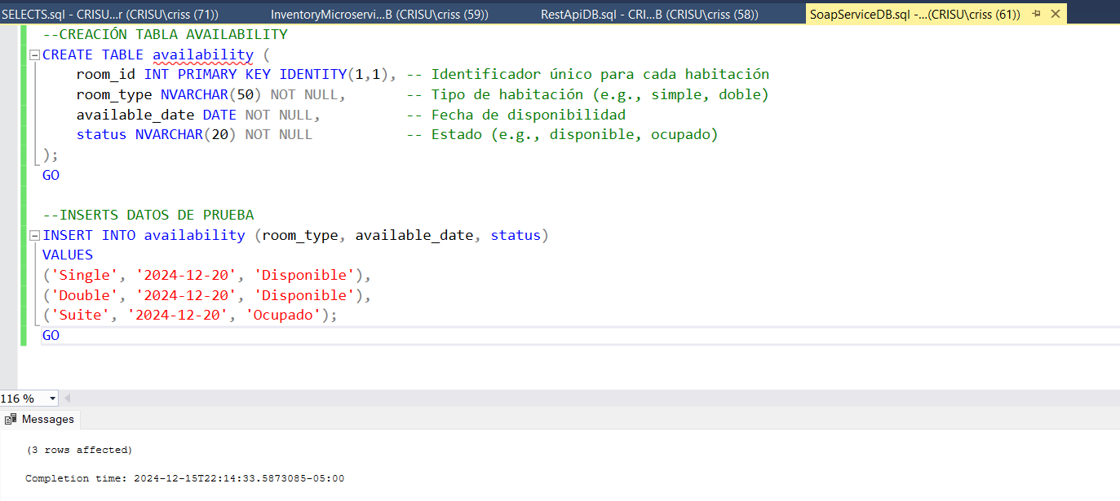

RestApi

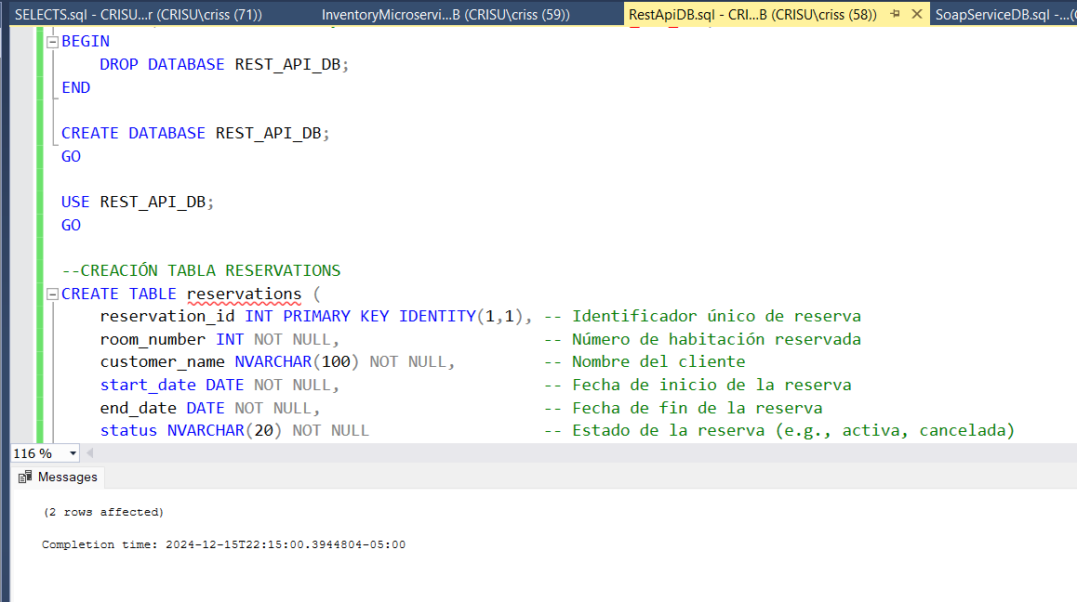

Inventory Microservice

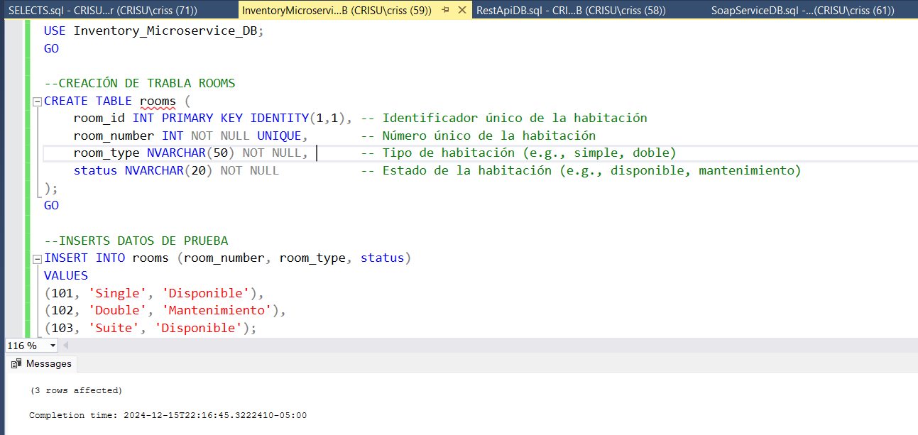

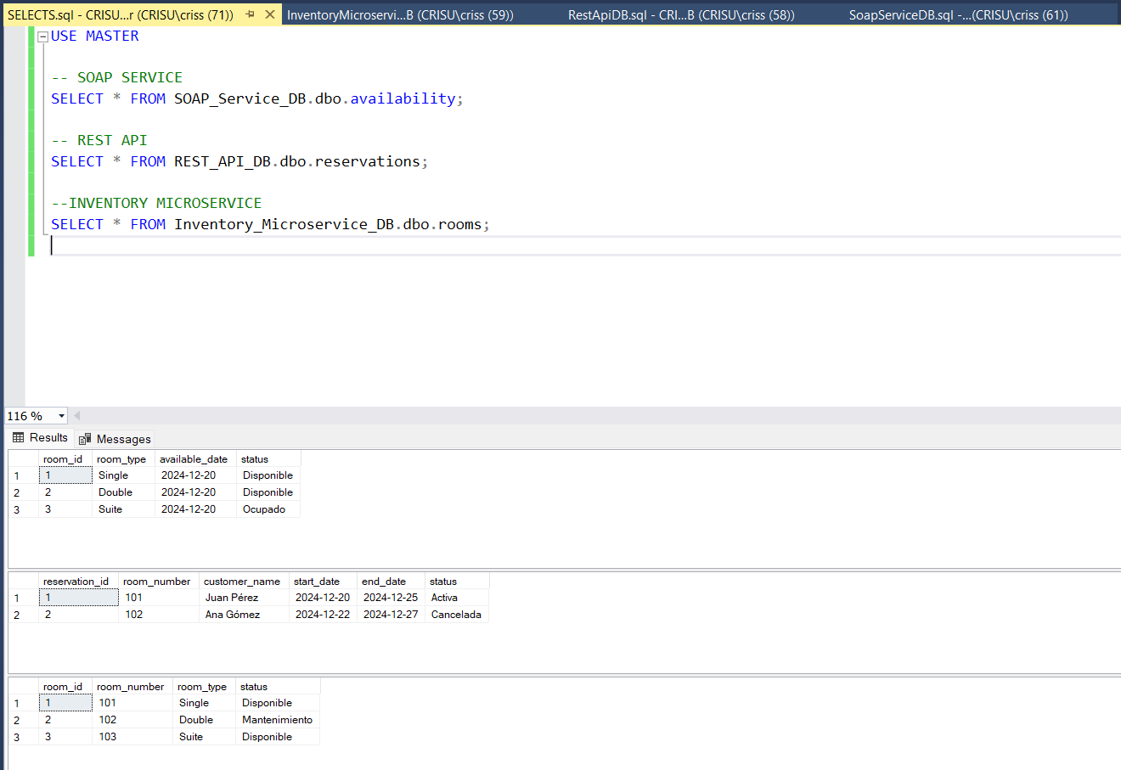

**Soap Backend Service**

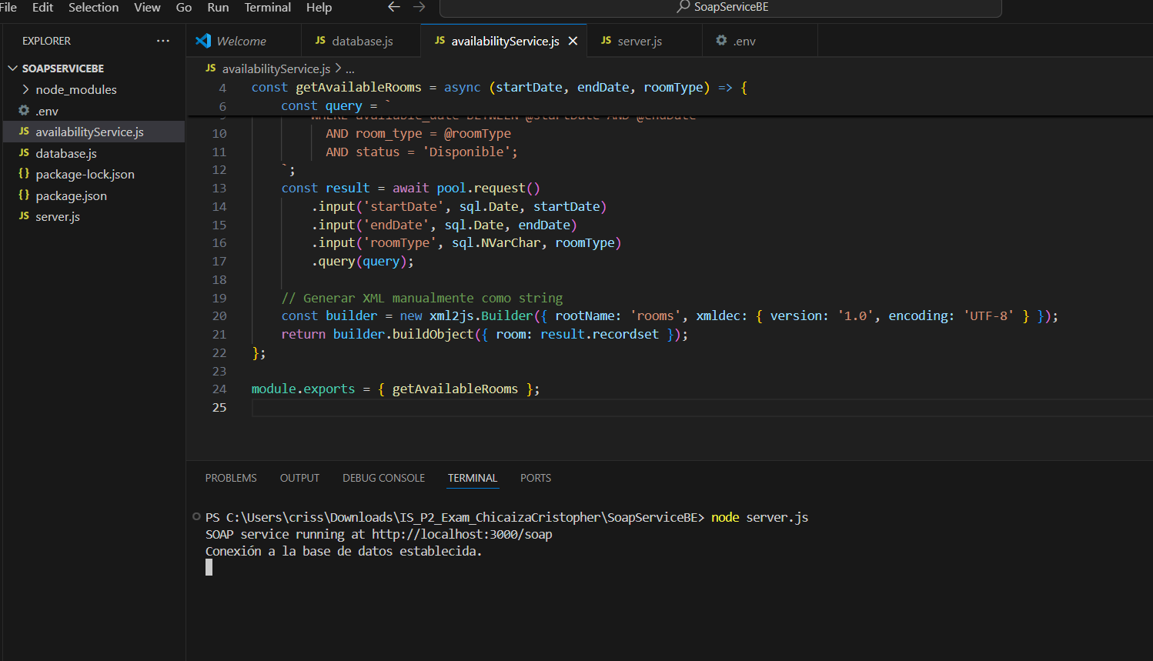

Test  
Datos:

URL: <http://localhost:3000/soap>

HEADER:

Key: Content-Type

Value: text/xml

Body XML:  
<soapenv:Envelope xmlns:soapenv="http://schemas.xmlsoap.org/soap/envelope/" xmlns:avail="http://example.com/availability">

   <soapenv:Header/>

   <soapenv:Body>

      <avail:CheckAvailability>

         <startDate>2024-12-20</startDate>

         <endDate>2024-12-21</endDate>

         <roomType>Single</roomType>

      </avail:CheckAvailability>

   </soapenv:Body>

</soapenv:Envelope>

Resultado:

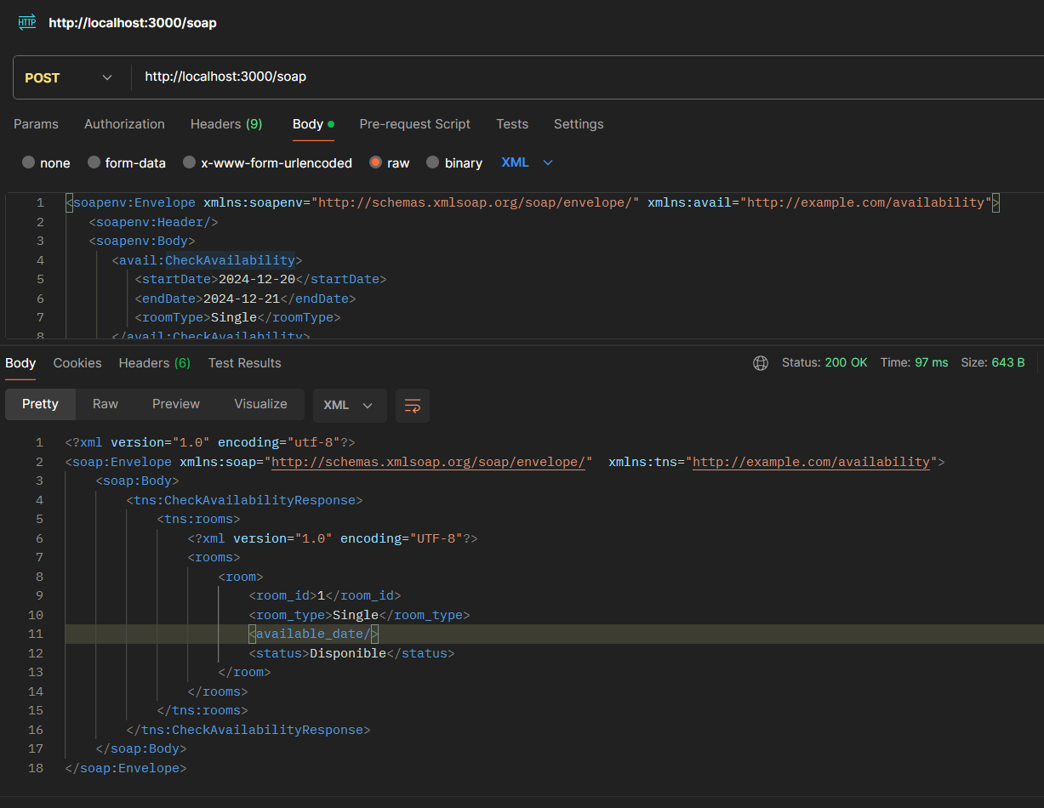

**Rest API Backend**

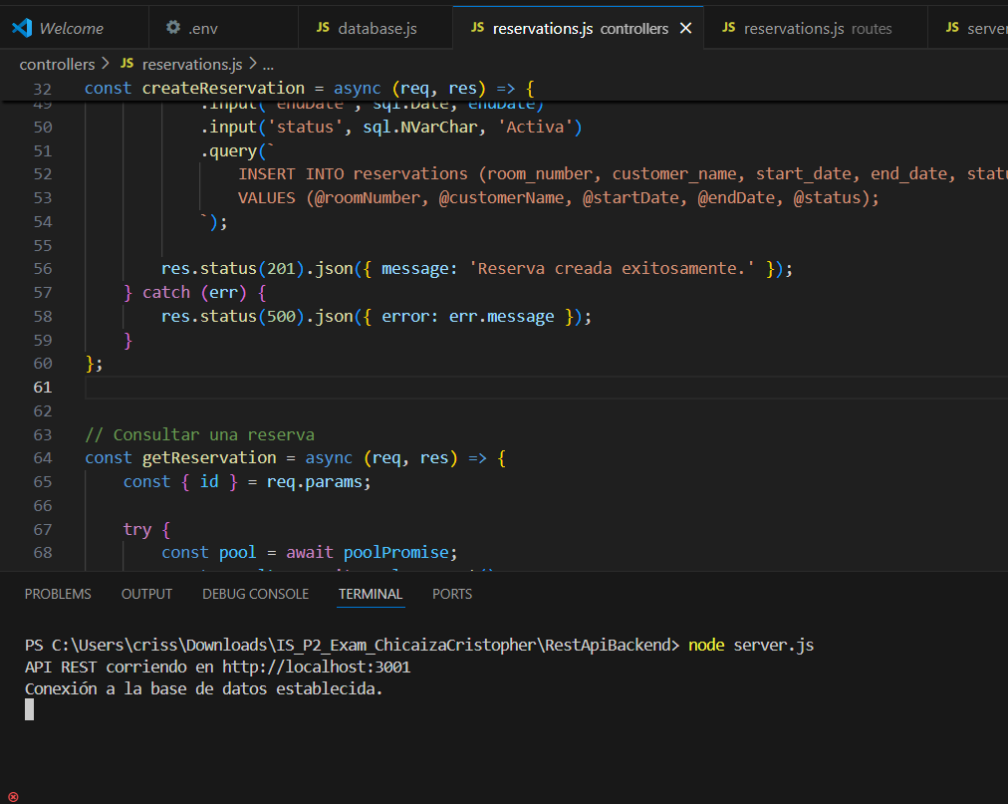

Pruebas:  
POST /reservations

URL: <http://localhost:3001/api/reservations>

BODY:  
{

    "roomType": "Single",

    "customerName": "Pedro López",

    "startDate": "2024-12-19",

    "endDate": "2024-12-22"

}

Resultados

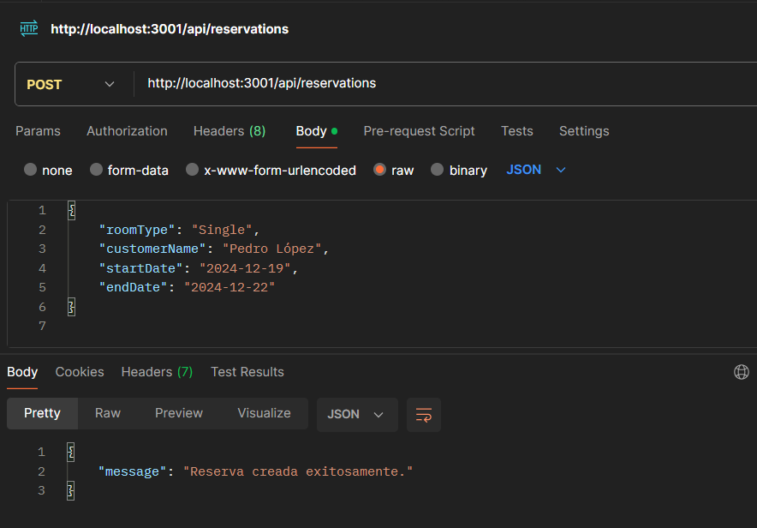

GET /reservations/{id}

URL: <http://localhost:3001/api/reservations/3>

Resultados:

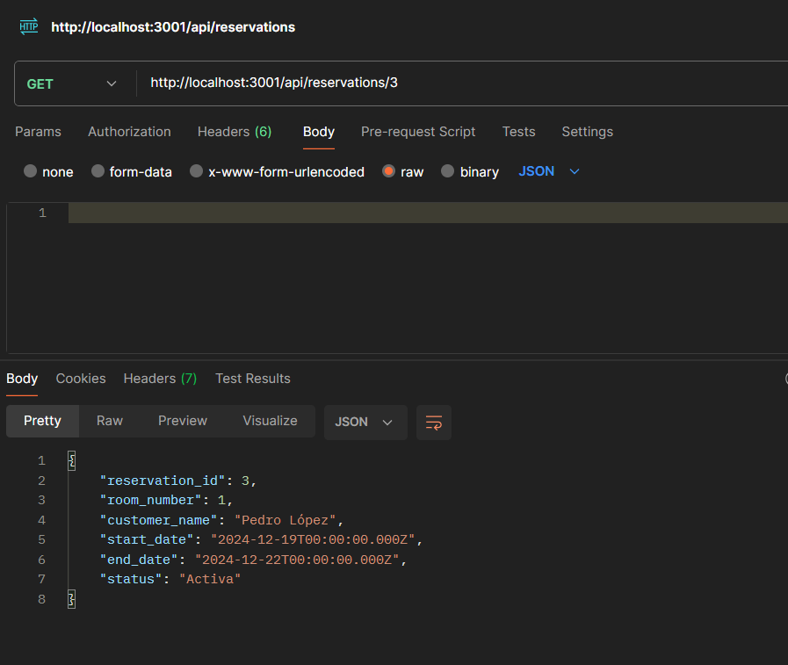

DELETE /reservations/{id}

URL: <http://localhost:3001/api/reservations/3>

Resultados:

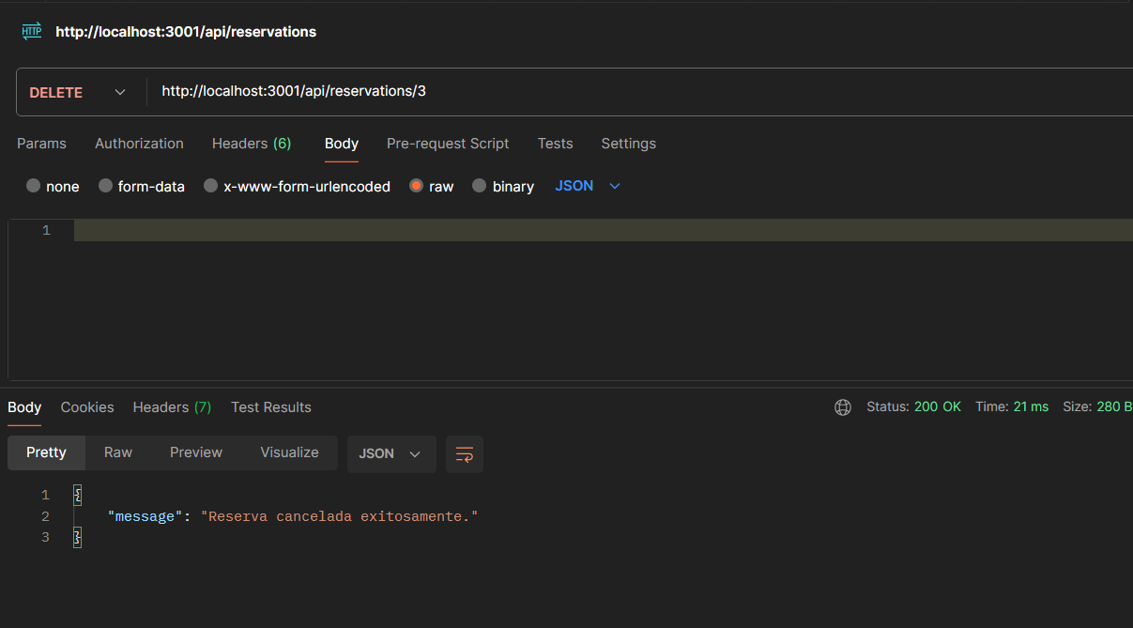

**Microservicio**

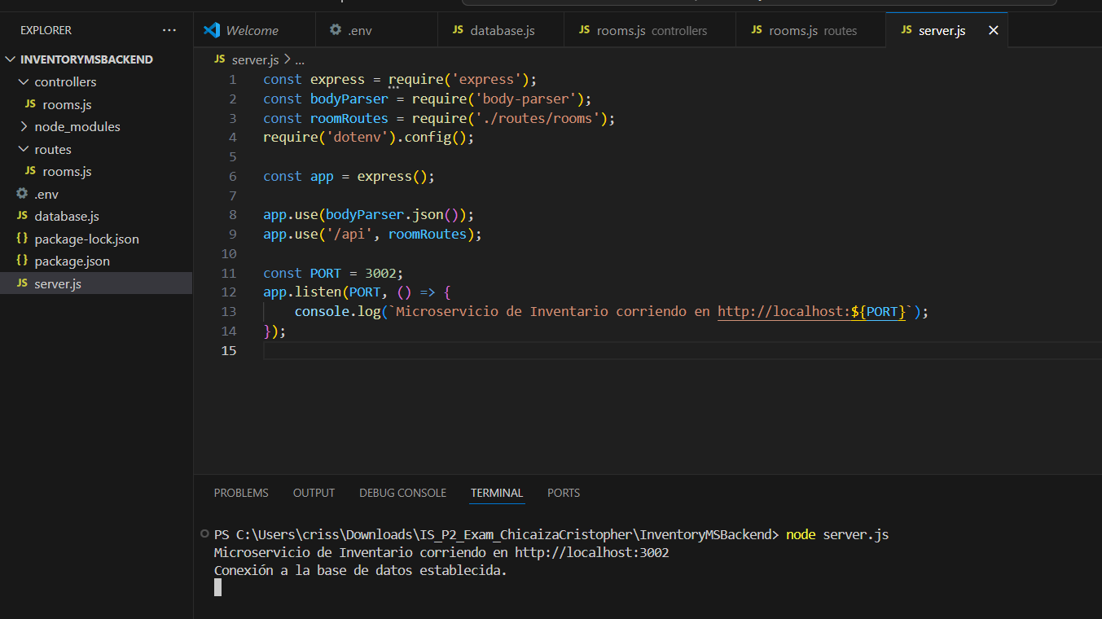

Pruebas:

POST /rooms

URL: <http://localhost:3002/api/rooms>

Body:

{

    "roomNumber": 104,

    "roomType": "Single",

    "status": "Disponible"

}

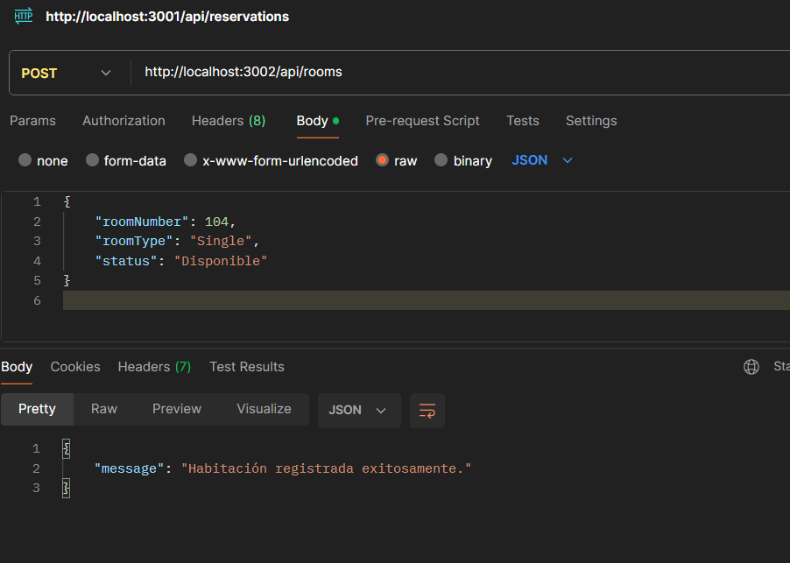

PATCH /rooms/{id}

URL: <http://localhost:3002/api/rooms/3>

Body:

{

    "status": "Mantenimiento"

}

